CV
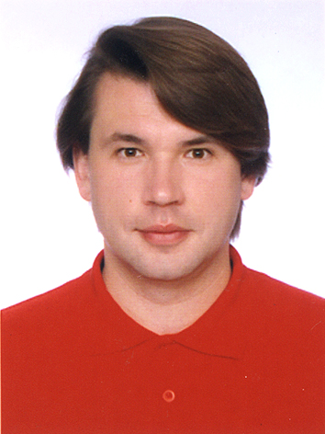

Name: Eduard Tkachuk

E-mail: wintermute2009@ukr.net

Objective: Design, development and maintenance of

Single Page Application (SPA) by AngularJS

(HTML5, CSS, LocalStorage, AJAX, XML, JSONP)

for Mobile Web (Android and other mobile OS).

SPA projects: E-Commerce (AngularJS+NodeJS+MongoDB)
LocalStorage DB (AngularJS+Cordova)
Project Management (AngularJS+Cordova)

Technical Skills: JavaScript (REST, AJAX, JSONP)
AngularJS (UI-Router, Bootstrap, Cordova)
NodeJS (Express, MongoDB, Bower, Gulp)
TDD (Karma, Mocha, Chai)
TypeScript (ECMAScript 2015)

Google Play Market: https://play.google.com/store/apps/developer?id=Eduard+Tkachuk

Experience: 2015-now - SoftServe, software developer.

2015-2015 - EPAM-Systems, software developer.

2013-2014 – self-employed, software developer.

2008-2013 - Ltd “Polymer-color”, software developer.

Education: National Academy of Sciences of Ukraine, Institute for Nuclear Research, PhD student.

Kyiv National Taras Shevchenko University, Faculty of Mechanics and Mathematics.

Languages: Russian(native), English (advanced).

